Kids Camp is coming up in Chattanooga!!! Sign Up today!
All students should register for the camp appropriate to the grade he/she has just completed.
Please contact Honi (907) 388-8298 if you are interested in registering or for more information.
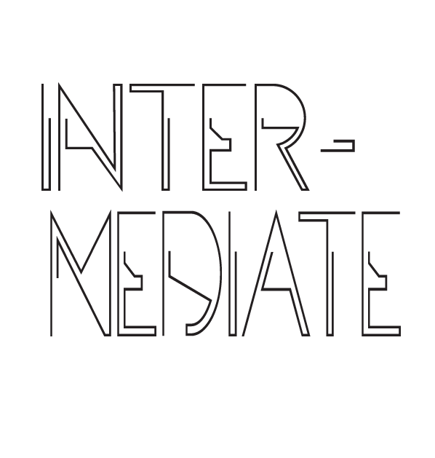

June 26-30
Grades 4-5

July 3-6
Grades 1-3

Camp Cost
To make camp the BEST WEEK EVER, a few changes to the 2017 camp season have been made.
$35 Non-refundable deposit due with application. Deposits and camp costs are NON-TRANSFERABLE! (This will be enforced.)
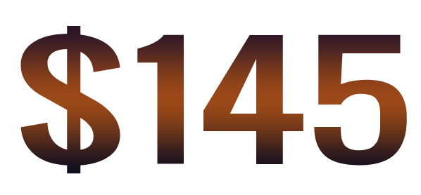

Regular Rate
Registered online after April 21 & before 2 WEEKS prior to camp.
**Includes T-shirt, Water Bottle & $10 Canteen!
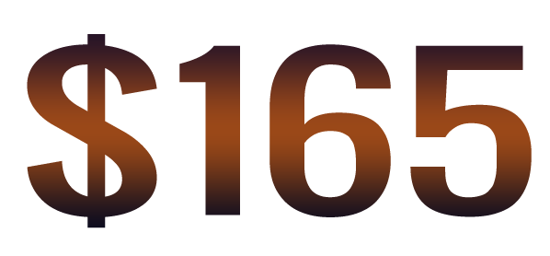

Walk-on Rate (Begins two weeks prior to designated camp!)
Registered within two weeks prior to designated camp.
Intermediate: June 13
Jr. Mini: June 20

