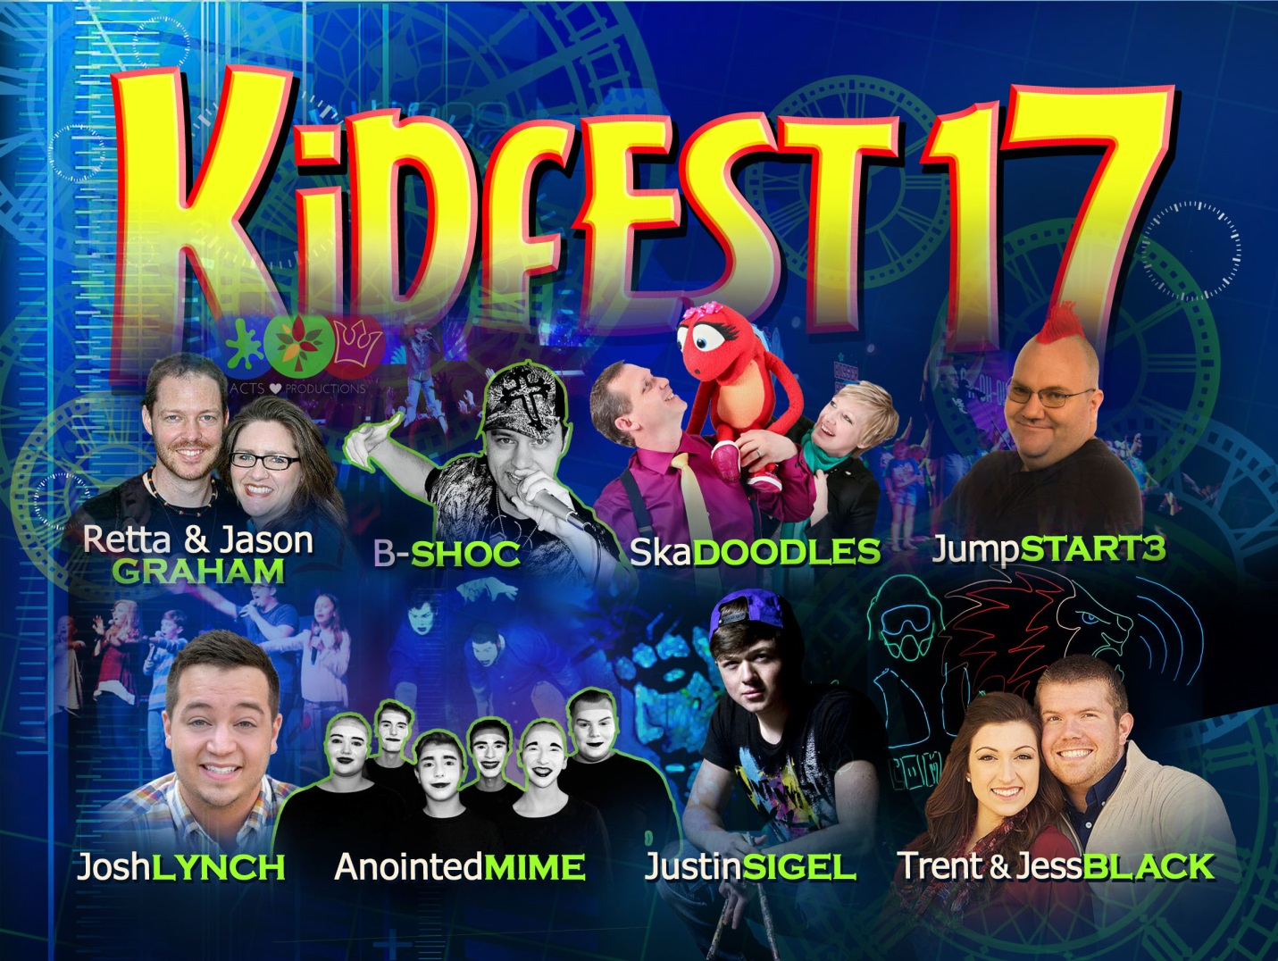
Join us for Fab time at Kidfest17! May 5th – 7th
We are SOOO excited to get the chance to enjoy this great event. B-Shoc will be there stirring up some crazy fun with a Holy Ghost party!!!
Never heard of him? Check out this link http://youtu.be/erj1k9sWbXc .
Please complete the attached forms and return to Honi the Children’s Ministry Coordinator. If you are able to pay for all or even only a portion of the cost please indicate below the amount and the Transformed Kids for Christ will work on fundraising for the outstanding amount. We want all of our 6-11 year old students to get the opportunity to attend this great event.
I am able to pay the full cost of $55.00_____
I am able to pay the amount of $______
I am not able to pay and need a full sponsorship______
Child’s name: __________________________________________

